# DECLARATION

I, **MWENDAPOLE**,Veronica,. declare that this project is not copied from anywhere and everything written in this booklet is done by myself. This project is submitted to National Institute of Transport in partial fulfillment of requirement for award of Bachelor Degree in Computer Science.

STUDENT NAME SIGNATURE DATE

**MWENDAPOLE**,Veronica ...………………… …………

# CERTIFICATION.

This is to certify that the project entitled, **SHOPPING GUIDER SYSTEM** submitted by **MWENDAPOLE**,Veronica in partial fulfillment of requirements for the award of Bachelor Degree in Computer Science at NIT is an authentic work performed under my supervision and guidance.

SUPERVISOR’S NAME. SIGNATURE DATE

**Sir. MARTIN MUSHI** …………….…. ……. …………

# DEDICATION.

This thesis is dedicated to my father, who taught me that “The best kind of knowledge to have been is that which is learned for its own sake”. It is also dedicated to my mother and my aunt, who taught me that “Even the largest task can be accomplished if it is done one step at a time”. Also, I would like to dedicate this project to my beloved supervisor **Sir** **MARTIN,Mushi** who accompany me in this project.

# ACKNOWLEDGEMENT.

Greatly I express my deepest thanks to the almighty God for his guidance throughout my life and studies for He is the one who enables me in this project.

This work was conducted under the guidance of my supervisor sir MARTIN Mushi, to whom I must express my sincere appreciation for the constant presence and support, which the present work reflects. I extend to him my grateful admiration. By competence, passionate and tireless support, I thank to my friend Fanuel Mwasampeta for the frequent and enriching exchange of ideas that offered me throughout this project.

My colleagues from CCT Department and out of CCT Department who supported me in this project work. I thank them all for their help, support, interest and valuable contribution to my work.

# ABSTRACT.

Guider shopping is small scale shopping which carry different products, this is a great challenge for blind people. Guider shopping is a proof-of-concept system designed to assist blind people shoppers with finding shelved products in the supermarket. Using synthetic verbal route directions and descriptions of the store layout, Guider shopping leverages the everyday orientation and mobility skills of independent blind people travelers to direct them to aisles with target products. Guider shopping was successfully used to guide blind people shoppers to multiple products located in aisles on shelves. Guider shopping is a feasible system for guiding blind people shoppers who are skilled, independent travelers. Its design does not require any hardware instrumentation of the store and leads to low installation and maintenance costs.

Contents

DECLARATION 1

CERTIFICATION. 2

DEDICATION. 3

ACKNOWLEDGEMENT. 4

ABSTRACT. 5

CHAPTER 1 8

INTRODUCTION 8

1.1 Problem Statement 9

1.2 Significance of the Project 9

1.3 Scope of the Project 9

1.4 Project Objective 10

1.4.1. Main Objectives 10

1.4.2. Specific Objectives 10

CHAPTER 2 11

LITERATURE REVIEW 11

2.1. Literature Review 11

2.1.1. WEAKNESS OF EXISTING SYSTEM 11

2.2. Preview of the Proposed Systems 12

CHAPTER 3 13

SYSTEM DEVELOPMENT METHODOLOGY 13

**3.1.** DATA COLLECTION 13

**3.2.** INTERVIEW 14

**3.3.** SYSTEM DEVELOPMENT LIFECYCLE 14

CHAPTER 4 19

SYSTEM REQUIREMENT SPECIFICATION 19

4.1. Functional Requirements 19

4.2. Non-Functional Requirements 20

CHAPTER 5: 21

SYSTEM DESIGN 21

5.1 Use Case Diagrams 21

5.2. Sequence Diagram 22

5.3. Data Flow Diagrams (DFD) 23

5.4. ERD Diagrams 25

5.5. Interface 26

CHAPTER 6: 27

6.1. TECHNOLOGIES USED IN IMPLEMENTATION 27

6.2. TESTING TECHNIQUES 27

CHAPTER 7: 30

CONCLUSION 30

7.1. System Limitation 30

**7.2.** Future Work 30

REFERENCES 32

**ss**

# CHAPTER 1

# INTRODUCTION

Different environments present different challenges to people with visual impairments. Some environments are challenging due to their large size or lack of structure, whereas other environments, although structurally regular, are functionally challenging due to the complexities of the tasks that must be performed in them. The list of the most functionally challenging environments for individuals with visual impairments is topped by shopping complexes

Unlike sighted individuals, many blind and visual impairments people do not shop independently. They typically rely on friends, relatives, volunteers, and store employees. When these individuals are unavailable, visual impairment shoppers have to reschedule or postpone shopping trips. When they go to the supermarkets by themselves, they experience delays, waiting for store employees to assist them. Some staffers are unfamiliar with the store layout, others become irritated with long searches and requests to read aloud product ingredients, and still others do not have adequate English skills to read the products' ingredients or answer basic questions about the supermarket layout. These difficulties cause blind and visual impairment shoppers to abandon searching for desirable products, settle for distant substitutes, or, in the worst case, abandon independent shopping altogether.

So, this system is designed in order to improve the quality of life for visual impaired people, in this system, I focused on the technologies to help those persons in the access of Shopping centers Therefore, this system providing as much information as possible for visual impaired people, allowing them to take a comfortable navigation and get product they want.

System provides a mechanism for navigation within supermarket and help visually impaired people ﬁnding speciﬁc products inside a supermarket, the system guides the user to the vicinity of the desired product with vocal instructions when he or she already wear microphone and ask to a system which product his or her wants, and user inputs may be received through voice instructions or using buttons on the device.

So, if the customer wants more than one product, the system localized everywhere and direction of travel calculated in order to plan route and deliver the right instructions to the user. Products location and route to a destination are calculated based on prepared map data, when a route is calculated, the user is guided to the destination through voice instruction

## Problem Statement

* Many people with visual impairments do not shop independently. They receive assistance from a friend, a relative, an agency volunteer, or a store employee. Depending on the assistant's availability, when these individuals are unavailable the shopper may need to postpone the shopping trip.
* When they go to the supermarkets by themselves, they experience delays, waiting for store employees to assist them
* Difficulties for them on searching for desirable products

## Significance of the Project

* To provide an assistance to blind users on going to the supermarket, ﬁnding speciﬁc products and traveling autonomously through the store.
* Provide several visual information that helps visually enabled people to move in a right way (e.g., takes a right direction, avoid obstacles, choose the shortest path to a destination)

## Scope of the Project

The subsequent analysis of the interviews about blind people on their shopping experiences, identiﬁed ﬁve subtasks of the generic grocery shopping task:

1. traveling to the store;
2. ﬁnding the needed grocery items in the store;
3. getting through a cash register;
4. leaving the store;
5. getting home.

This research focuses on the tasks such as ﬁnding the required products in the store, product localization, i.e., ﬁnding a product’s location on the shelves and traveling in the store. The scope of this investigation is focused to shopping for items stocked on the aisle shelves in a typical supermarket. The scope is further restricted to small-scale shopping. Tasks such as shopping for frozen products and produce as well as large-scale shopping are beyond the scope of this investigation. This research does not address the problem of product identiﬁcation, since it is not seen as a major obstacle. Well-managed stores maintain their shelves and the products on the shelves because their business depends on it. Employees regularly inspect the shelves to remove misplaced items, restock the sold items, and move items to the front of the shelf so that items are within easy reach. As long as a shopper picks up the product immediately above the shelf, product identiﬁcation will not be a major issue in most cases. Many people with visually impairments (blind people) have some residual vision that can help them identify products. Haptic cues can also be used to distinguish items, e.g., a peanut butter jar can be easily distinguished from a can of corn by touch. In the case of identical containers, either a second scan of the barcode on the product’s label or veriﬁcation at checkout could be used to resolve product questions. The problem of individual product identiﬁcation can most likely be solved with a combination of technical solutions, e.g., computer vision, and non-technical solutions that rely partly on the shopper’s intelligence and ability to adapt and partly on the willingness of the store to keep their customers satisﬁed.

## Project Objective

### 1.4.1. Main Objectives

* To develop guider shopping system for blind

### 1.4.2. Specific Objectives

* To create subsystem for voice instructions
* To create subsystem for requesting products
* To create subsystem for products route directions

# CHAPTER 2

# LITERATURE REVIEW

# 2.1. Literature Review

* Robot Cart

is a robot that guides the user to the vicinity of the selected product and helps ﬁnding it by scanning product barcodes on the shelves. As other systems, the ﬂoor of the store is converted into an RFID-enabled surface, where each RFID tag had its own 2D coordinates. This RFID tags are used as recalibration areas, when the robot reaches a recalibration area its localization is well known. A different system places voice emitter near sections on the supermarket that displays information when a person approach. Detection of proximity of a person is performed by infrared sensors, and the proximity distance can be set from 10cm to 50cm depending on establishment preferences. Information displayed can be used for costumer guidance, not only blind or visually impaired costumers. This system just delivers additional information to the blind user path, being the path deﬁnition customer’s responsibility.

* Shoptalk

Is a system designed to help visually impaired people ﬁnding speciﬁc products inside a supermarket, the system guides the user to the vicinity of the desired product with vocal instructions? A directed graph representing the topological map of the store is used for route calculations whose nodes are decision points like aisle entrances. Instructions delivered are set as done by user with a keypad, so the system is unaware of the user’s position or orientation. Product recognition is performed by scanning barcodes on the shelves, once a barcode is scanned and identiﬁed, user’s actual position is known. Although this system allows user positioning, guiding and ﬁnding speciﬁc products, it is a whole new device composed of a processor, a numeric keypad and a barcode scanner. Shop Mobile is a proposal updated version of Shoptalk running on a mobile phone. Barcode scanning is performed by mobile phone’s camera.

## 2.1.1. WEAKNESS OF EXISTING SYSTEM

As will be seen in the Related Work, Shoptalk and Robot Cart use devices that have attempted to address the need for navigation assistance in supermarket. Both have been developed using various technologies including GPS, Wi-Fi-based localization, RFID and infrared beacons. Unfortunately, the adoption rate for these devices in the blind community remains low. There are multiple reasons for this lack of adoption.

* First, the commercial devices tend to be expensive. For example, the software and GPS-based, guidance system Sendero GPS, intended to be used by an individual, costs $1,495, a price which does not include the mobile computer on which to run the software.
* Other navigation systems do not achieve localization accuracies that would be useful for a blind person in many situations, reports that its GPS units are accurate to within 15 meters. This amount of error may be acceptable for a sighted person who can make a visual distinction between where the device says the user is standing and where he is actually standing. For a blind person, an error of this amount reduces the usefulness of the device. If a blind person is continually given an inaccurate location, they may at best simply stop using the navigation device or at worst become disoriented and lost.

### 2.2. Preview of the Proposed Systems

This work proposes taking advantage of the previously unused sensor, the independent navigator, by viewing the user as an integral and active part of the navigation system. Research shows that the blind people prepare more for travel, make more decisions, and use more information than sighted travelers. Therefore, instead of designing yet another “you are here” type of system, this work proposes to design systems that provide more detailed and user appropriate levels of information. In this case, the more appropriate information is language route descriptions that describe how to travel a route. The hypothesis is that if a route is described with the suﬃcient and appropriate amount of detail, a blind person can use his everyday navigation skills and abilities to successfully follow the route without any wearable sensors or sensors embedded in the supermarket. This thesis has hypotheses that are addressed by the systems:

1. A Guider shopping system for the blind can leverage the skills and abilities of the blind people, and does not necessarily need complex sensors embedded in the supermarket to succeed.

2. Verbal route descriptions are adequate for guiding blind people when shopping in a supermarket for products on shelves located in aisles.

# CHAPTER 3

## SYSTEM DEVELOPMENT METHODOLOGY

## **3.1.** DATA COLLECTION

Data collection is defined as the procedure of collecting, measuring and analyzing accurate insights for research using standard validated techniques. A researcher can evaluate their hypothesis on the basis of collected data. In most cases, data collection is the primary and most important step for research, irrespective of the field of research. The approach of data collection is different for different fields of study, depending on the required information. Regardless of the field of study or preference for defining data (quantitative or qualitative), accurate data collection is essential to maintain the integrity of research. The selection of appropriate data collection instruments (existing, modified, or newly developed) and clearly delineated instructions for their correct use reduce the likelihood of errors. There are several methods for collecting data in research which are as follows, interview, questionnaires, observation, focus groups and more.

In this project I have used two method of data collection, interview and data collection has been done at Mabibo mini market.

## **3.2.** INTERVIEW

An interview is a face-to-face conversation between two individuals with the sole purpose of collecting relevant information to satisfy a research purpose. Interviews are of different types namely; Structured, Semi-structured and unstructured with each having a slight variation from the other.

**Why interview**

* Help to attain highly personalized data from the real user of the System
* Is rich in details it gives the many details compare to other data collection method
* Ensure investigates issues in an in-depth way
* Inform decision making, strategic planning and resource allocation Observation Using this technique we will gather accurate information about how the current system actually operates. We will also pass through other different materials that will related with project

## **3.3.** SYSTEM DEVELOPMENT LIFECYCLE

SDLC is a process followed for a software project, within a software organization. It consists of a detailed plan describing how to develop, maintain, replace and alter or enhance specific software. The life cycle defines a methodology for improving the quality of software and the overall development process.

The following figure is a graphical representation of the various stages of a typical SDLC.  
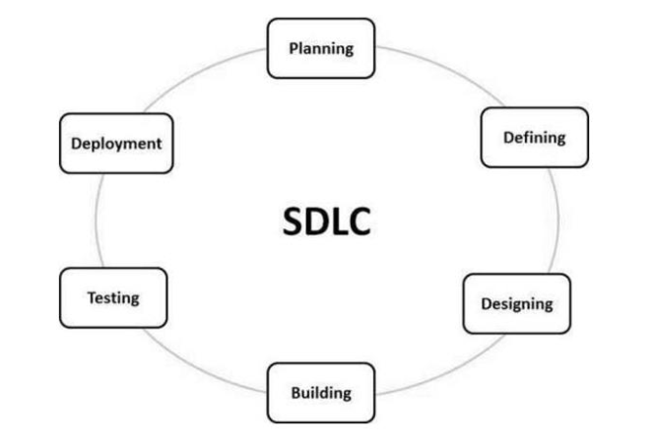

*Figure 4*: System Development Life Cycle

There are many different models and methodologies, but each generally consists of a series of  
similar defined steps or stages. Initiation, Feasibility, System analysis, System design, System  
build, System implementation and changeover, Review and Maintenance.

**SDLC - Iterative Model**

In this project I opted for Iterative model because the requirements were clearly known as well  
the system parts were easily parted according to the functionalities and requirements. In the  
Iterative model, iterative process starts with a simple implementation of a small set of the software requirements and iteratively enhances the evolving versions until the complete system is implemented and ready to be deployed.

An iterative life cycle model does not attempt to start with a full specification of requirements. Instead, development begins by specifying and implementing just part of the software, which is then reviewed to identify further requirements. This process is then repeated, producing a new version of the software at the end of each iteration of the model.

**Iterative Model – Design**

Iterative process starts with a simple implementation of a subset of the software requirements  
and iteratively enhances the evolving versions until the full system is implemented. At each  
iteration, design modifications are made and new functional capabilities are added. The basic  
idea behind this method is to develop a system through repeated cycles (iterative) and in smaller  
portions at a time (incremental).

The following illustration is a representation of the Iterative and Incremental model.

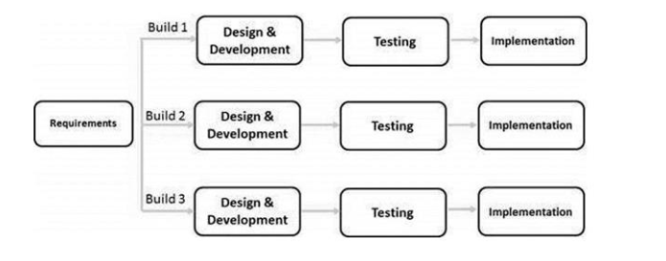

*Figure 5*: Iterative model

**Iterative Model – Application**

Like other SDLC models, Iterative and incremental development has some specific applications in the software industry.

This model is most often used in the following scenarios

* Requirements of the complete system are clearly defined and understood.
* Major requirements must be defined; however, some functionalities or requested  
  enhancements may evolve with time.
* There is a time to the market constraint.
* A new technology is being used and is being learnt by the development team while  
  working on the project.
* Resources with needed skill sets are not available and are planned to be used on contract  
  basis for specific iterations.
* There are some high-risk features and goals which may change in the future.

**Iterative Model - Pros and Cons**

The advantage of this model is that there is a working model of the system at a very early stage  
of development, which makes it easier to find functional or design flaws. Finding issues at an  
early stage of development enables to take corrective measures.

The disadvantage with this SDLC model is that it is applicable only to large and bulky software  
development projects. This is because it is hard to break a small software system into further  
small serviceable increments/modules.

**The advantages of the Iterative and Incremental SDLC Model are as follows;**

* Some working functionality can be developed quickly and early in the life cycle.
* Results are obtained early and periodically.
* Parallel development can be planned.
* Progress can be measured.
* Less costly to change the scope/requirements.
* Testing and debugging during smaller iteration are easy.
* Risks are identified and resolved during iteration; and each iteration is an easily managed milestone.
* Easier to manage risk - High risk part is done first.
* With every increment, operational product is delivered.
* Issues, challenges and risks identified from each increment can be utilized/applied to the next increment.
* Risk analysis is better.
* It supports changing requirements.
* Initial Operating time is less.
* Better suited for large and mission-critical projects.
* During the life cycle, software is produced early which facilitates customer evaluationand feedback.

**The disadvantages of the Iterative and Incremental SDLC Model are as follows**

* More resources may be required.
* Although cost of change is lesser, but it is not very suitable for changing requirements.
* More management attention is required.
* System architecture or design issues may arise because not all requirements aregatheredin the beginning of the entire life cycle.
* Defining increments may require definition of the complete system.
* Not suitable for smaller projects.
* Management complexity is more.
* End of project may not be known which is a risk
* Highly skilled resources are required for risk analysis.

# CHAPTER 4

## SYSTEM REQUIREMENT SPECIFICATION

This section lists both functional and non-functional requirement of the system

## 4.1. Functional Requirements

* System interacts with the blind by voice, and guides the person.
* System allow blind to request product.
* System allows guided and assisted navigation inside the supermarket by giving the start and end direction route of the product to the blind.

Guider Shopping is built on the explicit assumption that simple verbal route directions and layout descriptions can be used to leverage the everyday O&M skills of independent travelers to successfully navigate in the store.

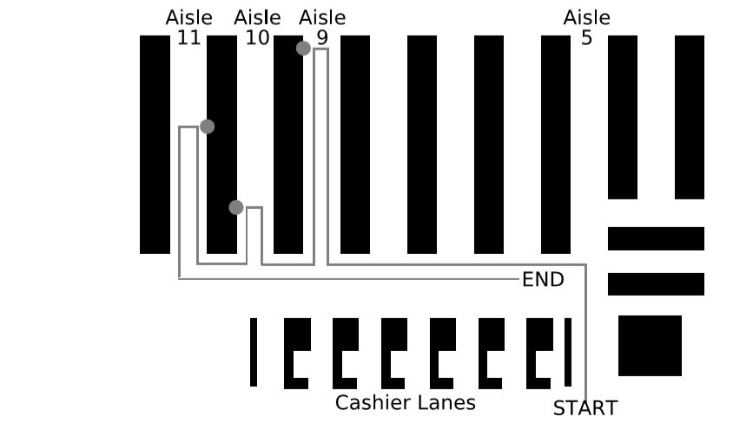

Fig. (1) Route map of the store used in the experiments. Dots represent the approximate locations of target products.

In Guider shopping, the environment is represented in data structures. The data structure is a topological map of the locomotor space. Guider shopping's topological map is given in Fig. (1) with a general map of the store. The topological map is a directed graph whose nodes are decision points: the store entrance, aisle entrances, and cashier lane entrances. Other decision points can be added as needed. The edges are labeled with directions. Due to the regularity of modern supermarkets and the constraints of our problem (small-scale shopping for items stocked on aisle shelves).I found it sufficient to have three directional labels: left, right, and forward. The topological map is the only software instrumentation requirement for Guider shopping to become operational. The map is built at installation time by walking through the store, noting decision points of interest, and then representing them in the map.

## 4.2. Non-Functional Requirements

* Performance: The system performance must be good enough to provide navigation services on-time, considering the users' movements, the walking speed.
* Usability. The use of the system should be as natural as possible for the end-users.
* Usefulness. The information delivered by the system must be useful and allow the users to navigate inside the supermarket properly, even if they are visiting those spaces for the first time
* Availability: The system must maximize the availability of its services independently of the environment where the user is located. Thus, the solution becomes usable in several built areas.
* Reliability: system should be reliable, by provide the ability and means

# CHAPTER 5:

## SYSTEM DESIGN

## 5.1 Use Case Diagrams

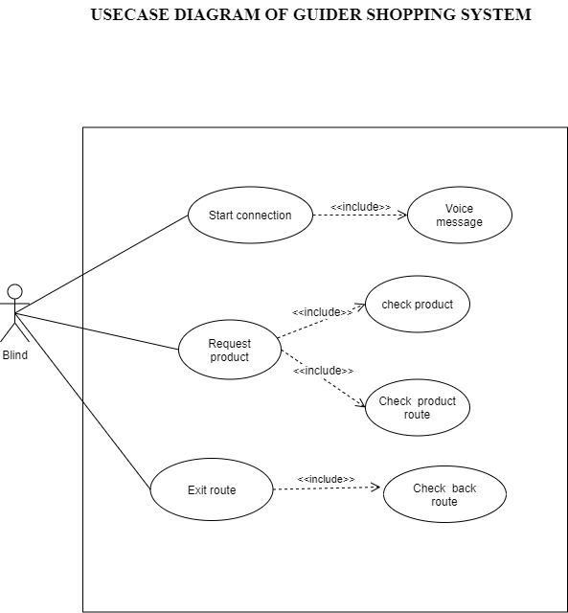

## 5.2. Sequence Diagram

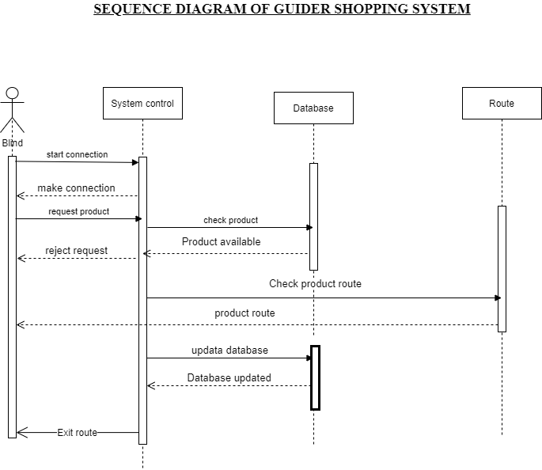

## 5.3. Data Flow Diagrams (DFD)

5.3.1. Data Flow Diagrams level 0

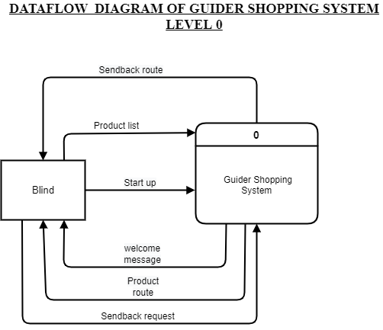

5.3.2. Data Flow Diagrams level 1

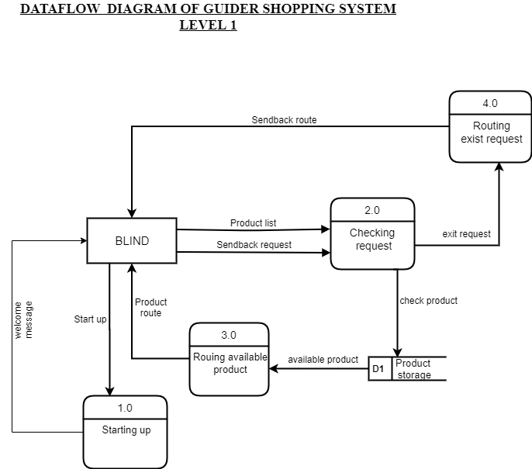

## 5.4. ERD Diagrams

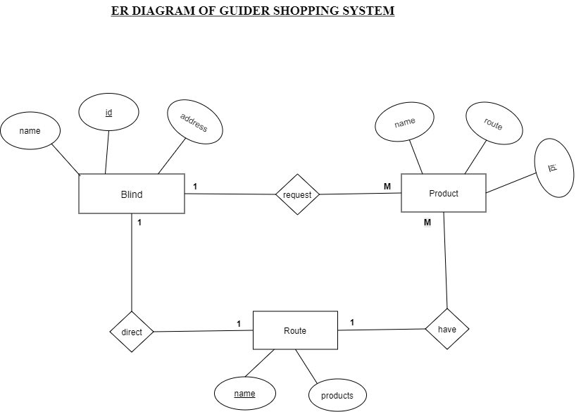

## 5.5. Interface

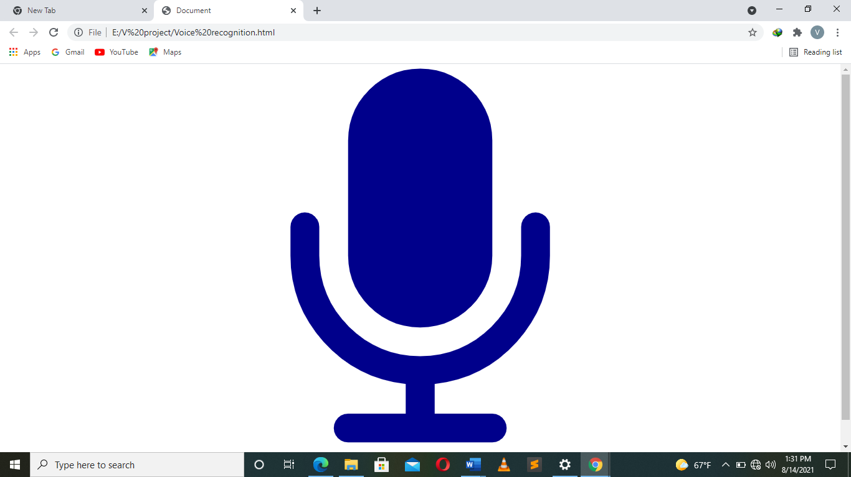

# CHAPTER 6:

During implementation of the system, the following are the key factors that were considered for successful implementation;

## 6.1. TECHNOLOGIES USED IN IMPLEMENTATION

Systems implementation is the construction of the new system or to developing the existing system and the delivery of that system into particular environment or organization (that can be used to, the day-to-day business or organization operation). Below are the programming languages and tools we

used to implement this system;

|  |  |  |  |
| --- | --- | --- | --- |
| **SN** | **NAME** | **DESCRIPTION** | **USES** |
| 1. | Sublime Text3 | Text Editor | Used for writing and editing html, CSS, and JavaScript |
| 2. | JavaScript | Font-End Language | Language used as a plat form for system development |
| 3. | Windows 10 | Operating System | manage the computer's resources, establish a user interface and provide services for applications software. |

## 6.2. TESTING TECHNIQUES

I developed a prototype of the architecture that was described in the previous chapter. In terms of experiments, I developed a set of test cases and tested both each module and the whole application according to those tests’ specifications. In order to do that, I related the requirements for each module, test cases and performed tests. As explained before, the system is composed of five different modules with distinct functions. In order to test the functionality and ensure the quality of each module, I developed small test applications for each one. The final application is the integration of all modules. The testing phase is used to evaluate the functionality of the systems.

Voice Module

The main function of the Voice Module is speech synthesis and voice recognition. A secondary function is the confirmation of the previous user input, which requires both speech synthesis and voice recognition. This module uses Google APIs for both the synthesis and the recognition.

Test Cases

The test cases were defined to validate the capability of the module to synthesize speech and to decrypt speech to text. Another function assigned to this module is the confirmation of the previous introduced information, which comprises both recognition and synthesis. This confirmation is used, in the user application, to request user confirmation for the selected destination. A simple application was created for testing the Voice module. This application includes just the three main functions of this module: synthesize text to speech, recognize speech, and the confirmation of introduced information.

Route Module

The Route Module has to calculate the shortest path between the user’s current location and the desired destination, a point of interest chosen previously. Therefore, this system interacts with the Information Module and Location Module for the background functionalities, and with the Voice Module to deliver navigation instructions to the user.

Test Cases

The Route Module was evaluated with a topological map of store. Test cases for this module intend to verify that the calculated route is actually the shortest between the start and end points, and that the module is strong enough to deliver the right navigation instruction at the right moment. At any time, the system has to be prepared to deliver help instructions. Help instructions may be related to the user’s current location or, in case a navigation is being performed, related to navigation orientations

Software Integration

This section presents the final software, which comprises the two modules previously detailed. This corresponds to a software integration test, where all modules are tested working together in a real case scenario. The requirements for the final application include the requirements of each separated module.

Test Cases

The software must enable the user to request the product, and must deliver the according navigation instructions that enable him/her to walk within the supermarket according to the products route and location.

# CHAPTER 7:

## CONCLUSION

## 7.1. System Limitation

* synthesis and voice recognition, require Internet connection. Voice synthesis is sufficiently fast, but voice recognition can be slow due to Internet connection properties and the Android device.
* during a navigation: the system assumes that the user is facing the direction of walking. The user is expected to follow the directions indicated by the system. If he changes direction inadvertently, the system is not yet equipped with the appropriate means to handle that situation. Therefore, the user would be expected to start a new navigation, facing backwards to the entrance of starting point.
* Starting a navigation from anywhere except a point-of-interest: currently, the system is only prepared to guide a person that starts navigating from starting point, if it is not a point of interest and the person is facing different direction can get lost. This is because the system does not have an orientation device, therefore it cannot determine which direction a person is facing.

## **7.2.** Future Work

The work presented on Guider Shopping proposes alternative approaches to assistive navigation technology for independent blind travelers. Both systems still have unexplored questions and other avenues for research. This chapter details future work and research for the system.

* The first obvious area of work is the hardware. There are several reasons why the hardware should be addressed. First, Guider Shopping is primarily a software solution. In order for a Guider Shopping -like system to be widely adopted, it should be capable of running on common, commercial, and relatively cheap hardware. In order for Guider Shopping to be adopted, the stores must be able to afford the device. Second, the current hardware is a large and bulky design that is not ergonomic. Smaller hardware would be easier to store between uses, have lower power requirements, and be easier to carry while shopping.
* Another limitation of the reported experiments was that the system was only used to locate products on shelves in aisles. In order for Guider Shopping to become a more full featured tool that can address the full shopping experience, other areas of the grocery store need to be handled by the system. Other store areas to be mapped include:

1. Refrigerator and freezer units requiring shoppers to open a door.

2. Refrigerator units with no doors. These units are similar to shelves except they have bottom areas that hold the cooling units and extend out from the shelves. Another 147 style are the large, refrigerated boxes that shoppers reach down into from an open top.

3. Deli and bakery areas that may or may not have people working behind a counter and food behind glass barriers. It may simply be the case that Guider Shopping is unable to guide all shoppers to all areas and all products in a store. Yet, if the system can be used to find the majority of items in a store, it will still be useful to blind people.

* A final limitation of this work is that it does not address how to build the shopping list. There are two types of shopping, planned shopping and spontaneous shopping. In planned shopping, a person makes a list of all items that need to be bought. In spontaneous shopping, the shopper is already at the store and decides that an item that is not on the planned shopping list is needed. Adding this functionality to Guider Shopping would complete the shopping experience and ensure that Guider Shopping allowed blind people to perform the entire shopping experience independently and shopper can request product from anywhere and starting to navigate to the final destination according to the defined route.

# REFERENCES

Kulyukin, V., Kutiyanawala, A.: Accessible Shopping Systems for Blind and Visually Impaired Individuals: Design Requirements and the State of the Art. The Open Rehabilitation Journal (to appear)

J., Kulyukin, V.: ShopTalk: Independent blind shopping = verbal route directions + barcode scans. In: Proceedings of the 30th Rehabilitation Engineering and Assistive Technology Society of North America (RESNA), Phoenix, Arizona (2007)

Lanigan, P.E., Paulos, A.M., Williams, A.W., Rossi, D., Narasimhan, P.: Trinetra: Assistive technologies for grocery shopping for the blind. In: International IEEE-BAIS Symposium on Research on Assistive Technologies (RAT), Dayton, OH (2007)

CHUMKAMON Sakmongkon, TUVAPHANTHAPHIPHAT Peranitti and KEERATIWINTAKORN Phongsak, A Blind Naviagtion System Using RFID for Indoor Environments. 5th International Conference on Electrical Engineering/Electronics, Computer, Telecommunications and Information Technology. ECTI-CON 2008. 14-17 May 2008. 28

Yan Zhang, SUNet ID: yzhang “Speech Recognition Using Deep Learning Algorithms”

Kulyukin V, Gharpure C, Nicholson J. RoboCart: Toward robotassisted navigation of grocery stores by the visually impaired. In: Proceedings of the IEEE/RSJ International Conference on Intelligent Robots and Systems (IROS). Edmonton, Canada: IEEE Press 2005; pp. 2845-50.